Research Paper Title: Predictive Modeling of Customer Attrition in
Retail Banking: A Comparative Analysis of Ensemble Learning and
Explainable AI (XAI)

ABSTRACT
This project focuses on Customer Segmentation and Churn Pattern Analytics in European Banking using machine learning techniques. The main objective of the study is to identify customer groups that are more likely to leave the bank and analyze the factors influencing churn behaviour. The dataset contains customer demographic, financial, and engagement-related information such as age, geography, balance, credit score, and activity status. A Random Forest Classifier was used to build the churn prediction model, achieving good prediction accuracy. Exploratory Data Analysis (EDA), feature importance analysis, and SHAP explainability techniques were applied to understand the major drivers of customer churn. The study found that age, account balance, geography, and inactive membership significantly influence customer churn. The findings of this project can help banks develop targeted retention strategies and improve customer satisfaction.
Introduction
Customer churn refers to the situation where customers discontinue their relationship with a company or financial institution. In the banking sector, customer churn is considered a major challenge because losing existing customers can reduce profitability and increase customer acquisition costs. Retaining customers is more cost-effective than attracting new customers, making churn analysis extremely important for banks.
With the increasing competition in the financial sector, banks need advanced analytical methods to understand customer behaviour and identify customers who are at risk of leaving. Customer segmentation and machine learning techniques help financial institutions analyze demographic and financial patterns more effectively. By identifying churn-prone customer groups, banks can design personalized services, improve customer engagement, and implement better retention strategies. This project uses customer data from European banking institutions to analyze churn patterns and build a predictive model for customer retention analysis.
Methodology & Feature Engineering
The study utilized a standardized dataset, subjected to rigorous data cleaning and feature engineering.
The final model included 14 features:
Original Features: Credit Score, Geography, Gender, Age, Tenure, Balance, Number of Products, Has
Credit Card, Is Active Member, and Estimated Salary.
Engineered Features:
Balance-to-Salary Ratio: Measuring financial leverage.
Product Density: (NumOfProducts / Tenure).
Engagement Score: (NumOfProducts * IsActiveMember / Tenure).
Preprocessing: Categorical variables were transformed via One-Hot Encoding, and numerical variables
were standardized using Z-score scaling.

Results
Overall Customer Churn Distribution (Pie Chart)

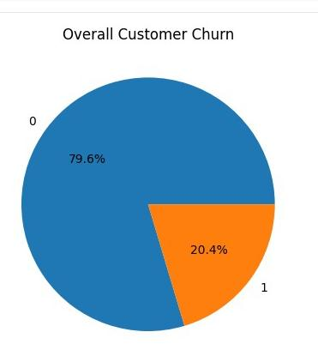

Interpretation
The pie chart represents the overall distribution of retained and churned customers in the banking dataset. The majority of customers remained with the bank, while a smaller percentage exited the banking services. Although the retention rate is comparatively high, the churned customers still represent a significant business concern. This indicates the need for effective customer retention and engagement strategies to reduce customer loss.

Geography-wise Churn Analysis

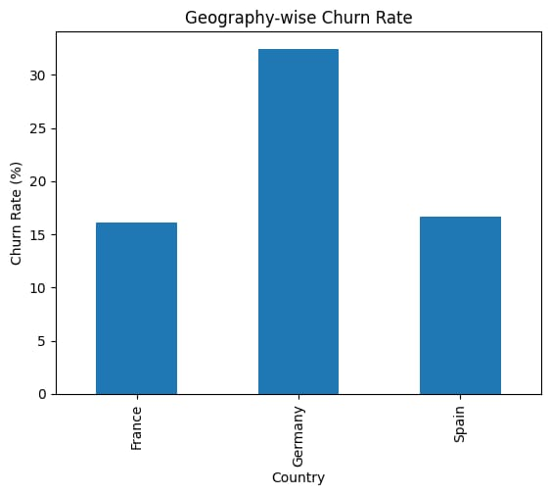

Interpretation
The geography-wise churn chart compares customer churn across France, Germany, and Spain. Germany recorded the highest churn rate among the three countries, indicating relatively higher customer exit behavior in that region. France showed better customer retention compared to the other countries, while Spain demonstrated moderate churn levels. The analysis suggests that geographical location significantly influences customer churn behavior and regional retention strategies may be required.

Age-wise Churn Analysis

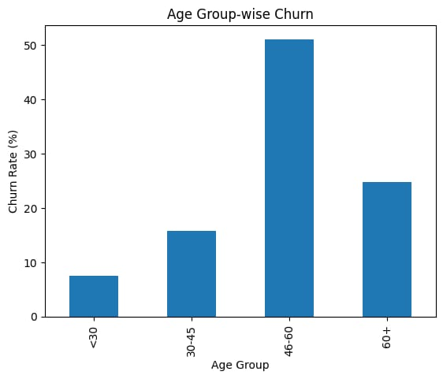

Interpretation
The age-wise churn chart shows the relationship between customer age and churn behavior. Middle-aged customers, particularly those between 30 and 60 years, exhibited higher churn probability compared to younger customers. Younger customers below the age of 30 showed relatively lower churn rates. The findings indicate that customer age plays a major role in banking behavior and customer retention patterns.

Tenure-wise Churn

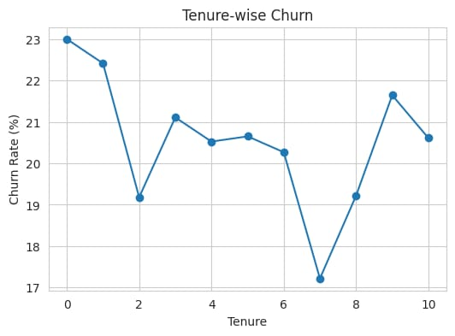

Interpretation

The tenure-wise churn chart shows that customers with fewer years of association with the bank are more likely to churn. Long-term customers demonstrate better loyalty and lower exit rates. This indicates that strengthening customer relationships during the initial years can significantly improve customer retention.

Random Forest Feature Chart

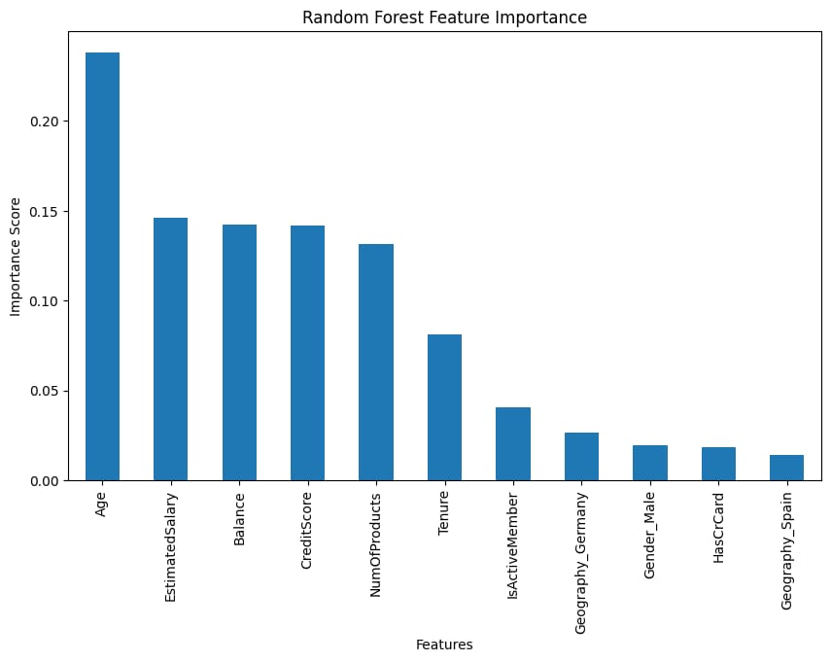

Interpretation
The Random Forest Feature Importance chart identifies the variables that most strongly influence customer churn prediction. Features such as age, account balance, activity status, and geography showed higher importance scores compared to other variables. This indicates that demographic characteristics, financial behavior, and customer engagement significantly affect churn behavior.

SHAP Feature Chart

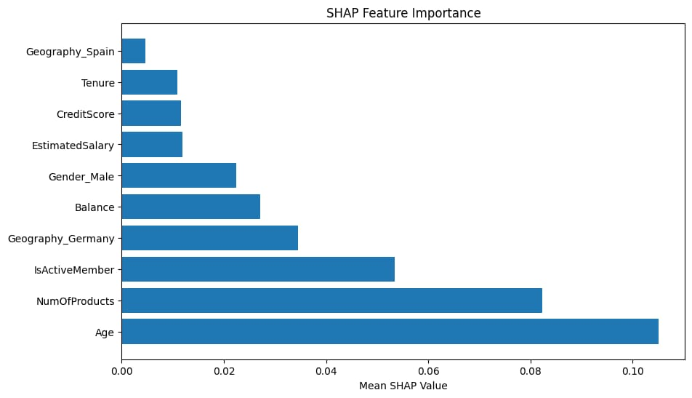

Interpretation
The SHAP Feature Importance chart ranks the features based on their influence on churn prediction. Variables such as age, balance, activity status, and geography showed the highest SHAP importance values. These features contribute significantly to customer churn prediction and provide valuable business insights for customer retention strategies.

Correlation Heatmap
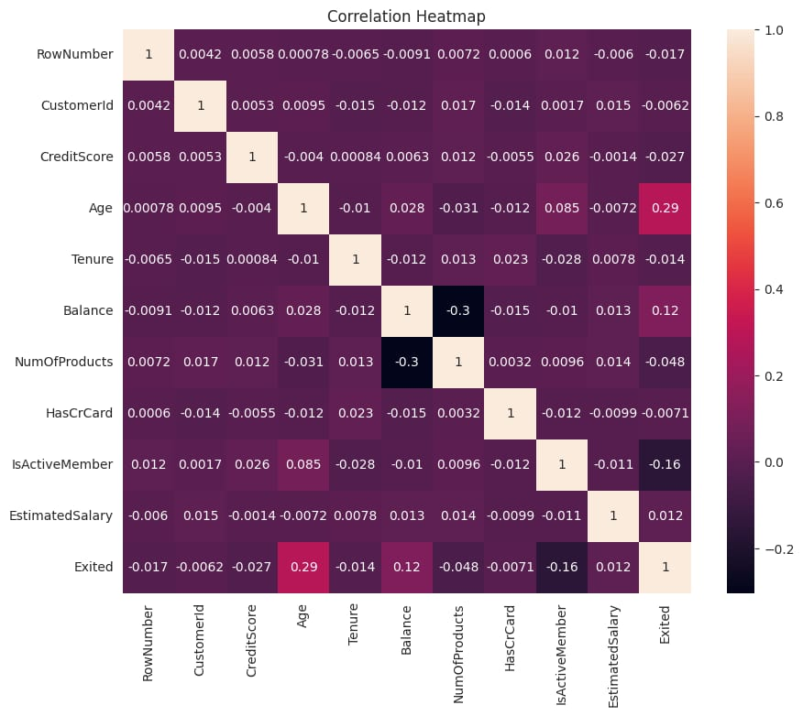

Interpretation
The correlation heatmap shows the relationships between different numerical variables in the dataset. Age and account balance displayed noticeable relationships with customer churn, while active membership showed a negative relationship with customer exit. The heatmap helps identify important features that influence churn behavior and supports effective machine learning model development.

CONCLUSION
The project successfully identified major customer churn factors using customer segmentation, exploratory data analysis, machine learning, and SHAP explainability techniques. The Random Forest Classifier demonstrated strong predictive performance in identifying customers at risk of leaving the bank. The analysis revealed that age, geography, balance, and customer activity significantly influence churn behaviour. The findings of this project can help banking institutions design targeted customer retention strategies, improve customer engagement, and reduce revenue loss caused by customer churn.

